Brief of the tour report of Dr. J.P. Singh, Consultant (OS) for uploading on the website of NMOOP

- Summary of the visit

S.No. | Name & Designation of the visiting Officer | Visiting period |  | State and district covered | Crops covered
 |  | From | To
1. | Dr. J.P. Singh, Consultant (OS) | 19.08.2014 | 21.08.2014 | Bargarh and Bolangir districts of Odisha | Groundnut and Oil Palm

- Salient observations

  - The groundnut crop, which was largely sown during 1st fortnight of July was at pod formation and in good condition except infestation of aphid, white grub and tikka due to continuous heavy rains.

  - Larger seed production programmes of new varieties of groundnut namely Kadri-6 (2005), ICGV-91114 (2007), TG-37-A (2004), TG-38 (2006), has been organized over an area of about 1500 ha during Kharif-2014 under Seed Village component of NMAET through District Agriculture Department, who has identified the farmers and supplied breeder/foundation seed.

  - Excellent growth and bearing of FFB in 03 year old plantation of Oil Palm and successful inter-cropping of banana with Oil Palm in district Bargarh.
3. Actionable points:
The State Government may expedite necessary follow-up action on the following issues.

  - Organize an orientation programme for implementation of NMOOP.
  - Issue of guidelines in regional language.
  - Issue of district wise action plan and release of funds immediately to ensure implementation of MM-I in Rabi – 2014-15.
  - Completion of inspection of seed plots of groundnut registered under Seed Village Programme.
  - Exposure visit of oil palm growers to the successful Oil Palm growers’ fields with intercropping of Banana at village Barla Bhal, block Barpalli and village Patra Pally (without intercrop), Bhatli block, district Bargarh for encouraging area expansion under oil palm.

  - Directorate of Rapeseed & Mustard Research, Bharatpur may organized a training of field functionaries and progressive farmers of Odisha on mustard cultivation and FLDs on short duration varieties of mustard like Pusa Mehak (81-114 days), Pusa Agrani (95 days), Shatabdi (90-105 days), Pusa Tarak (100-120 days) and Pusa Bahar (108 days) in mustard growing district of Odisha for productivity improvement of rapeseed & mustard in the State.

4. Photographs (for photo gallery)
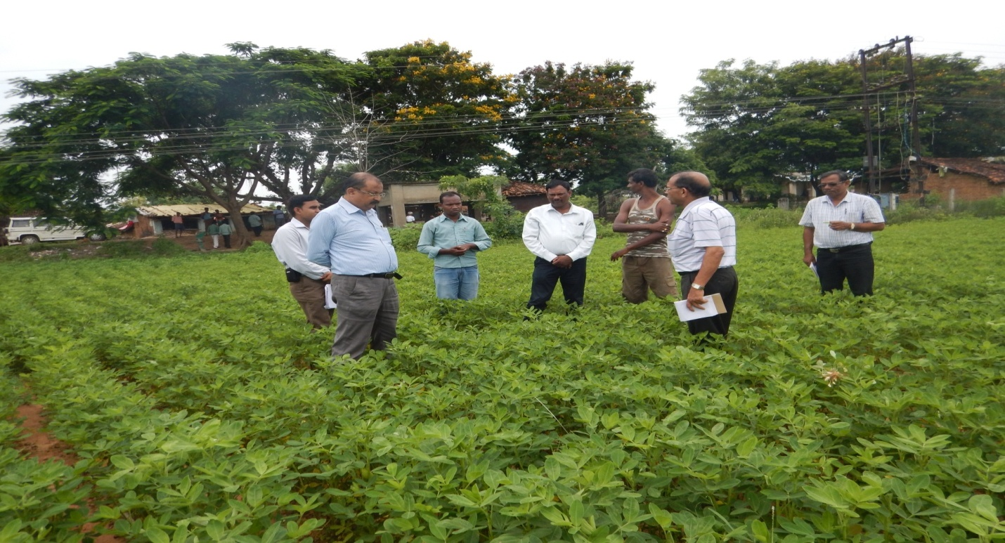
Seed plot of certified seed of kadri-6, village Saplahar, Paikmal block
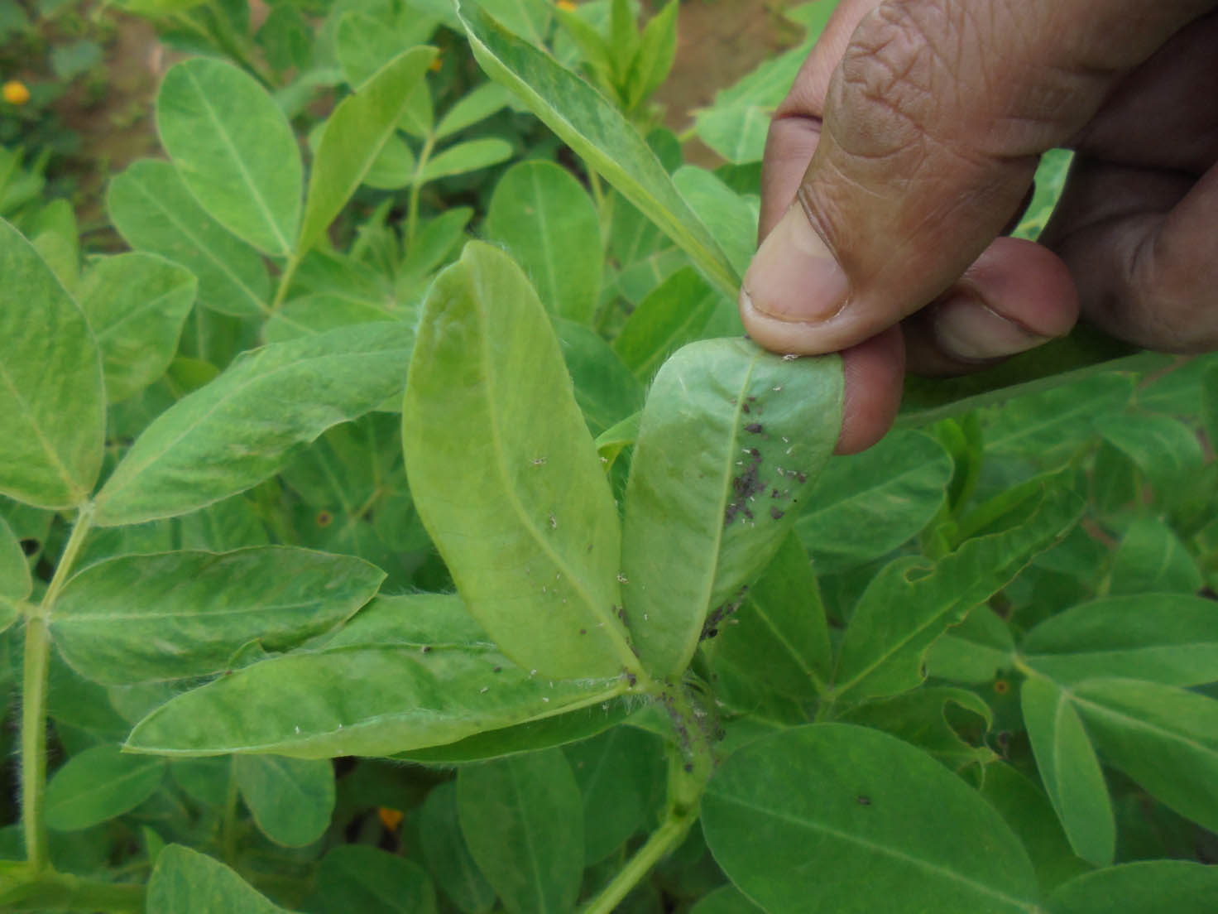
Infestation of aphid in groundnut

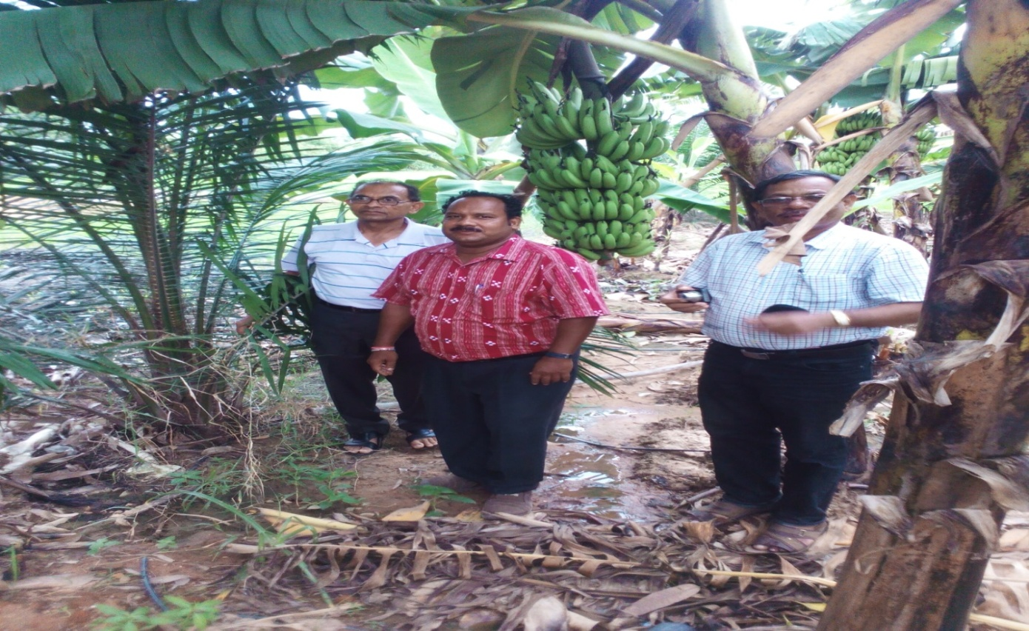
Successful intercropping of Banana with Oil Palm plantation at village Barla Bhal, block Barpalli, Bargarh district of Odisha

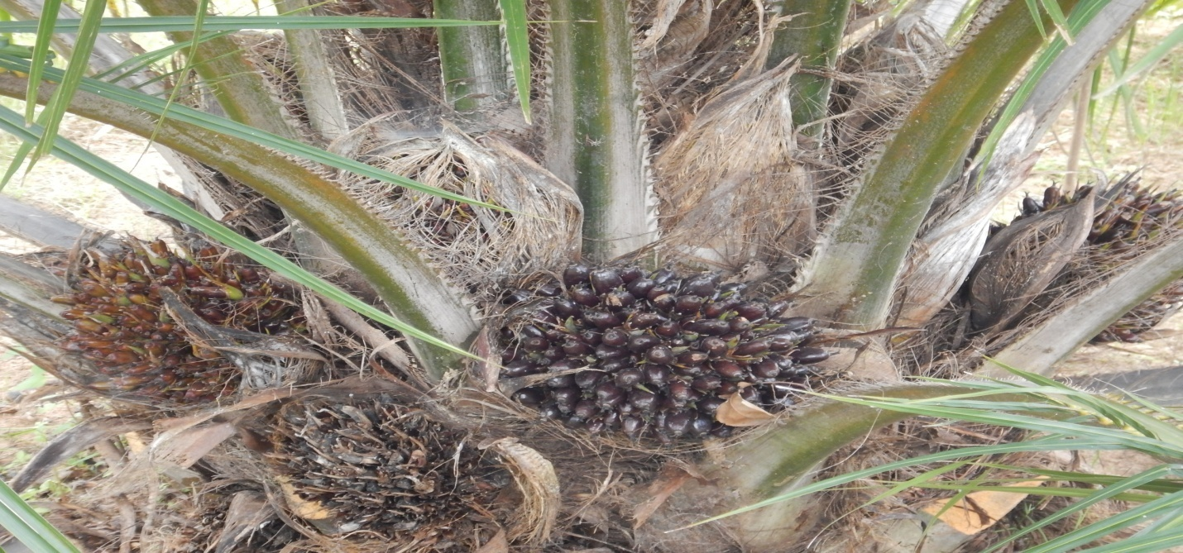
Excellent growth and bearing of FFB (12) in 3 years old plantation of Oil Palm at village Patrapalli, Bhatli block of Bargarh district of Odisha

********

