TOUR REPORT OF SHRI S.K.DALAL, CONSULTANT, OILSEEDS
FOR HIS FIELD VISIT TO ANDHRA PRADESH
(from 11th to 14th July, 2016)

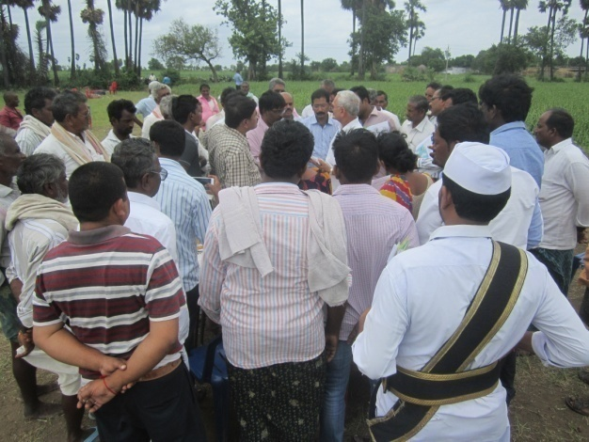
I visited Andhra Pradesh and covered Guntur, Parkasam and Krishna districts. After arrival at Vijaywada went state for field visit in Guntur district to observe the implementation kharif pulses programme. Shri Sridhar JDA (Crop Sciences), Dr. NDRK Sarma, State Consultant joined the visit from State HQ. Shri Kaagi, Assistant Director from Directorate of Oilseeds, Hydrabad participated in Parkasm district visit. During the visit discussions were held with the officers of department of agriculture working at district, division, mandal and village level. Similarly, interaction was held with the farmers in their fields who were happy with implementation of both the GoI programmes namely, National Food Security Mission (NFSM) and National Mission on Oilseeds and Oil Palm (NMOOP). While interacting with the farmers, it was informed due to diversification from commercial crops like cotton to pulses, there would be higher production of pulses and thus the prices are likely to fall. Therefore, it was requested that better prices for their produce may be assured.

- Ongoing agricultural field operations in the State

- Sowings of rainfed crops like bajra, jowar, maize, ragi, redgram, greengram, blackgram, groundnut, sesamum, sunflower, castor, chillies are under progress in all districts.
- Early sown crops like greengram, blackgram, sesamum are in vegetative growth and some are at flowering stage.
- Paddy is at nursery to transplantation stage.

- Weather conditions

- The State
The South West monsoon which is crucial for agriculture sector entered Rayalseema region in Andhra Pradesh (AP) on 9th June, 2016 and spread over entire State on 18th June. During the month June there was actual rainfall of 158.8 mm, which was 69.5% excess as compared to normal rainfall of 93.7 mm. The actual rainfall during July is 23.4mm (59% deficit) as against normal rainfall of 56.7 mm (as on 13.07.2016). However, there is an overall 21% excess rainfall so far (182.2 mm against normal rainfall of 150.4mm)

- The District-wise
As on 13.07.2016, the region-wise rainfall is excess in north & south coastal region whereas normal in rayalseema region. As regards district-wise rainfall, the position is normal in 6 districts and excess in 4 districts so far. The district-wise rainfall received from South West monsoon for the period from 01.06.2016 to 13.07.2016 is given in Annexure- I .

- Targeted area for pulses

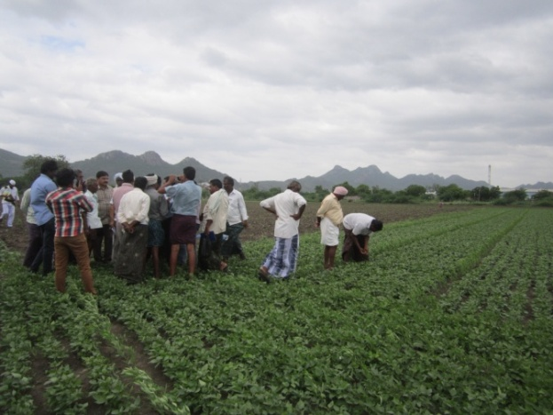
The State has targeted an area of 17.29 lakh ha for the year 2016-17 out of which 4.90 lakh ha during kharif 2016 and 12.39 lakh ha in Rabi 2016-17. The State has proposed very ambitious target of area coverage of 4.90 lakh ha as against normal area coverage of 2.53 lakh ha during Kharif 2016. Redgram alone has area coverage target of 3.00 lakh ha as against normal area of 1.86 lakh ha.

The crop-wise and season-wise details of area coverage targets for pulses in given below:
Area in lakh ha.
Crop | Normal Area during Kharif season | Targets |  |  | Area sown (as on 13.07.16)
 |  | Kharif 2016 | Rabi 2016-17 | Total
Redgram | 1.86 | 3.00 | 0.02 | 3.02 | 0.33
Greengram | 0.23 | 0.70 | 2.50 | 3.20 | 0.08
Blackgram | 0.23 | 0.60 | 4.75 | 5.35 | 0.03
Horsegram | 0.13 | 0.40 | 0.22 | 0.62 | 0.00
Bengalgram | 0.00 | 0.00 | 4.75 | 4.75 | 0.00
Other pulses | 0.08 | 0.20 | 0.15 | 0.35 | 0.013
Total pulses | 2.53 | 4.90 | 12.39 | 17.29 | 0.46

- Area sown under kharif pulses (Crop wise)

The crop-wise area coverage so far is 65% as against the normal season, whereas 33% as against projected kharif target. It was reported that since first fortnight of July received deficit rainfall, the area coverage has been slowed down which is likely to pick up again during July and will continue till mid August. So the field officers are very hopeful to achieve the proposed targets of pulse crops. Moreover, since the planting of redgramm would be made on the bunds of rice fields, the area coverage will continue till sowing of rice crop in the State. The sowing season of rice crop has started and transplanting operations are picking up in irrigated areas where water reservoirs have good storage for release in canals.

The district-wise area sown so far under redgram, greengram, blackgram, horsegram, other pulses and total pulses is given in Annexure-II.

- Availability of inputs for kharif pulses:

A. Seed
There is no shortage of availability of certified seeds of area-wise desired varieties of pulses in the state. The required quality of seed was placed in the district outlets well in advance before on set of rains. The district wise position of pulse seed is given in Annexure-III.

B. Seed minikit
In the state the varieties of LRG-30 for redgram and P4-31 for black gram allotted by GOI of distribution under seed minikits in pulses during 2016-17 to popularize cultivation by farmers.

- Seed production and distribution:
The seed production programme of desired varieties of different crops is taken up by the Andhra Pradesh State Seed Development Corporation (APSSDC) and no shortage of quality pulses seed in the State was reported. The details of variety-wise availability and distribution of pulse crops seed is given below:

Crop / Variety | Target | Availability | Distribution
Redgram
LRG - 41 | 14380 | 15063 | 12106
ICPH - 2740 | 255 | 255 | 255
Greengram
LGG - 460 | 4925 | 5146.13 | 2164.06
IPM - 2-14 | 250 | 248 | 248
Blackgram
PU - 31 | 4812 | 6469 | 5065.2
LBG - 752 | 3901 | 225 | 60
Total | 28523 | 27406.13 | 19898.26
The State officials have assured to send the details of targets of seed production for 2016-17 to produce certified seeds of desired and promising varieties of pulses.

- Availability of fertilizer, micro nutrients including Sulphur and PP chemicals:

The nodal agencies / institutes identified for supply of inputs like seed, fertilizer, micro-nutrients, sulphur, soil ameliorants like lime & gypsum are Andhra Pradesh State Seed Development Corporation (APSSDC), AP Markfed Ltd, APSAIDC Ltd, ARS Amravati etc. The indented input material is supplied at an interval of 7 to 10 days to the mandal level Agriculture Officer for onward distribution to the doorstep of the beneficiaries. The source of sulpur is through gypsum, SSP, AS etc which is promoted in pulses cultivation based on soil tests.

During Kharif 2016, total supplies of various fertilizers made so far is 5.60 lakh MTs and 8.24 lakh MT of fertilizer is available for distribution to the farmers. The details of district-wise plan, supplies and availability of various fertilizers during Kharif, 2016 is given in Annexure- IV.

- Monitoring of Pests and Diseases

During field visit no disease / pest infestation was observed. In the State, at district level, the Joint Directors of Agriculture, Assistant Directors and Agricultural Officers & MPEOs are monitoring pest surveillance in pulse crops.

- Major initiatives taken by Govt. of Andhra Pradesh

- For achieving targeted growth in agriculture 15 key performance indicators were identified.
- Issuing of Loan Eligibility Cards - “The Andhra Pradesh Land Licensed Cultivators Act, 2011” dated 23.12.2011, to provide loan and other facilities eligibility cards (LECs) to the farmers.
- More focus on farm mechanization.
- Introduced Interest free loans to the farmers
- Focus on organic & natural farming.
- For nutritional security special focus on millets.
- Formation of FPOs to fetch better price providing linkage & value addition.

- Drought proofing measures initiated by the State

The State has targeted to supply 15,497 no. of rain guns to cover an area of 9.3 lakh ha for providing life saving irrigation in rainfed areas particularly in pulses and oilseeds. The mandal-wise mapping of frequent drought areas has been completed. Efforts will be made that water is available in farm ponds for dry spell mitigation.

Under moisture conservation furrows method 1.30 lakh ha area would be covered under groundnut, redgram, cotton, blackgram, maize etc in rainfed areas. Deep ploughing will be popularized to break hard pan in light soils which will conserve more rain water during monsoon. This would be taken up with sub soilers in an area of 65,000 ha.

A Contingency Plan workshop has been conducted in coordination with CRIDA and SAU scientists and district-wise contingency plans have been prepared.

Efforts would be made for collection of ground water by linking of bore wells, sharing of the water amongst the farmers and imposing ban on excavation of new bore wells. This technology is being adopted in 1000 ha in Ananthapur district and 500 ha each in Chittoor and Kurnool districts.

The Govt. of A.P. has submitted a proposal for climate resilient agriculture to the IFAD for financial assistance to mitigate drought and farmers distress in 4 Rayalaseema & Prakasam districts.

- Strategies for improving production, productivity and cost reduction

- Increase in total cropped area in the State :9.86 lakh ha
(from 61.28 lakh ha to 71.14 lakh ha)
- Promotion of moisture conservation furrows
in the rainfed crops like redgram,
groundnut and cotton etc. : 1.3 lakh ha
- Promotion of poly cropping system : 0.36 lakh ha
- Promotion of redgram crop on bunds of rice
and other commercial crop : 1.0 lakh ha
- Promotion of inter crop of pulses in
groundnut, cotton , millets etc. : 2.0 lakh ha
- Promoting pre-kharif crops with pulses and
sesamum under NSP and KWD : 53,000 ha
- Promotion of summer pulses duly advancing
the cropping season under Godavari and Krishna
delta system by June : 2.00 lakh ha
- Target for providing agricultural credit to the farmers : Rs. 83,000 crores.

- Strategies for area expansion and productivity enhancement

- Redgram
- Promoting inter cropping with other crops like groundnut, cotton;
- Growing hybrid ICPH-2740 variety of redgram in an area of 40,000 ha on rice and other commercial crops field bunds.
- Transplanting of redgram for productivity enhancement;
- Use of micro nutrients like zinc, gypsum in an area of 46,000 ha based on soil tests;
- Planting of redgram under drip irrigation for high productivity;
- Timely pest management through neem oil at flower bud initiation;
- Creating water conservation furrows;
- Life saving irrigation using rain-gun during dry spell.

- Blackgram & Greengram
- Increasing the area in rice fallow as well as summer pulses;
- Promoting sowing as kharif crop under NSP and KWD areas;
- Two crop sequence under rainfed during karif / rabi in place of mono-cropping (blackgram / greengram followed by bengalgram)
- Foliar spray of potassium nitrate in saline soils;
- Seed treatment with bio-fertilser and fungicides;
- Timely pest management at flower bud initiation to reduce maruca;
- Management of YMV disease;
- Micronutrient application based on soil tests.

- Bengalgram
- To increase an area of 8501 ha during rabi 2016-17 as compared to 2015-16;
- Foliar application of potassium nitrate in saline soils;
- Use of micro nutrients like zinc, gypsum in an area of 78,500 ha based on soil tests;
- Life saving irrigation using rain-gun during dry spell.

- Nodal Officer at State level

Smt. D.S.S.Suseela,
Additional Director of Agriculture,
Commissionate of Agriculture,
Govt. of Andhra Pradesh,
Guntur (AP)

OBSERVATIONS AND SUGGESTIONS

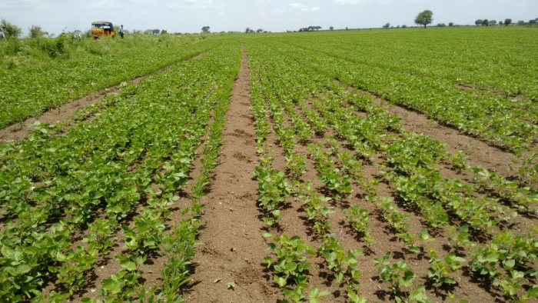
- In the State, due to timely arrival and wide spread South West monsoon in beginning of June, the pulse crops have very good vegetative growth stage and at some places, flowering has just started in case of blackgramm & greengram.

- The achievement so far (as on 13.07.2016) with respect to area coverage of pulses is 65% as against normal season. As reported there is a forecast for more rains after 20th July, it is expected that pulse kharif 2016 targets fixed by the State would be achieved.

- The State has taken number of initiatives for drought proofing in rainfed areas where pulses and oilseeds are commonly grown. It is expected that the area expansion and productivity enhancement of pulse crops would be possible during Kharif 2016 through moisture conservation, intercropping, planting of redgram on rice bunds etc.

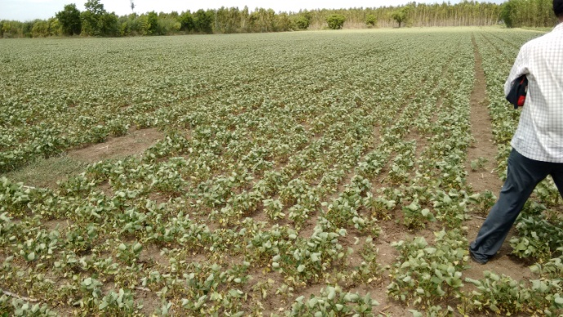
- It was observed during the course of visit in Parkasam district that plants of blackgram crop in a cluster demonstration sown at time of first showers were withering / wilting. The officers of agriculture department were advised for allowing 2% spray of potassium nitrate / urea to serve as a tool that delay wilting at least for a week when second showers of rain are expected as per forecast. This was taken up with the Commissioner of Agriculture and on spot decision was taken to supply fertiliser by the department and sprayer to be arranged by the farmers of the region.

- In addition to growing redgram on rice bunds and inter cropping, the State should also encourage summer pulses under paddy fallow to increase cropping intensity and concentrate on higher productivity with protective irrigation where ever possible.

- In rainfed areas, the places may be identified which has water in farm ponds to promoted growing of pulses where sowing can be taken up after good rainfall and life saving irrigation can be arranged through rain guns from pod water.

- In view of higher coverage / production of pulses the farmers are expecting fall in prices of their produce and during interaction requested for assured procurement prices and enhancement of Minimum Support Price (MSP). They have also requested for establishment of mini dal mills near their villages. The It was informed that some of the central programmes like NFSM, NMOOP, RKVY there is a provision of flexi funds for local initiatives which can be proposed for such activities.

