Package of Practices (PoP) of Sunflower (Helianthus annuus )
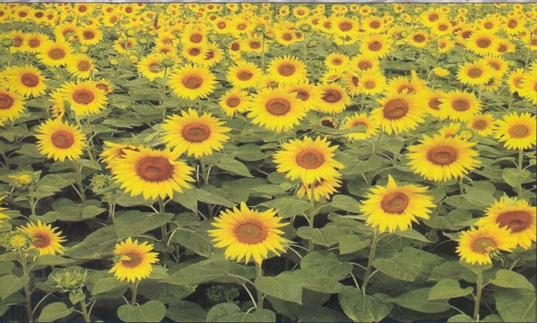
- Climate and soil:- Sunflower can be cultivated in all the seasons but perform better during Rabi or spring/early summer. It performs well in deep, neutral and well-drained light as well as heavy soils.

- Sowing time:- Sowing time should be so planned that the flowering and seed filling stages of the crop do not coincide with continuous rainy period or high temperatures above 38°C.

- Seed treatment:- Seed should be treated with Thiram or Captan @ 2-3 g/kg of seed to protect from seed-borne diseases. Seed treatment with Metalaxyl @ 6 g/kg can protect the crop against downy mildew disease. Treat the seed with imidacloprid @ 5 g/kg before sowing against insect vectors for the necrosis management.

- Seed rate:- A seed rate of 5 kg/ha is adequate to achieve required plant population of 55,000/ha under heavy soil and 74,000/ha under light soils. Maintenance of optimum population by judicious thinning at 10-15 days after germination to retain single healthy plant per hill is essential for obtaining optimum yields.

- Spacing:- The optimum spacing is 60 cm between rows and 30 cm between plants which can accommodate 55555 plants/ha. For short duration and dwarf varieties, 45 cn x 30 cm spacing may be followed.

- Nutrient Management:-
- Sunflower is an exhaustive crop and for every tonne crop removes as much as 63.3 kg nitrogen, 19.1 kg phosphorous, 126.2 kg potacium, 11.7 kg sulphur, 68.3 kg calcium, 26.7 kg magnicium, 47g zinc and 1075 g iron. Application of nutrient may be decided as per soil health card.
- Boron is the most important for sunflower. Providing directly spray of borax (0.2% i.e. 2 g/l of water) to capitulum at ray floret opening stage increases seed filling, yield and oil content.
- Sulphur is emerging as fourth major nutrients especially for oilseeds due to its involvement in oil synthesis. Sunflower has been found responsive to direct and residual sulphur fertilisation.
- Seed treatment with Azospirillum and/or Azotobacter can save 50% recommended nitrogen fertilizers. Similarly, use of PSB in sunflower – sorghum cropping system can meet 50% of phosphorous requirement of sorghum (30kg P₂O₅/ha).

- Weed Management:- Two hoeings followed by one hand weeding at an interval of 15 days commencing from 15-20 DAS. Use of alachlor or pendimethalin or fluchloralin at the rate of 1.0 kg a.i./ha in 600 litres of water as pre-emergence spray followed by one hand weeding and inter-culture at 35 DAS provide effective control of weeds.

- Water Management:- Protective Irrigation is essential at three critical stages of bud initiation, flower opening and seed filling.

- Pest and diseases Management:-
- Cut worm – sow the seeds on ridges
- Capitulum borer – Spray Decametrhrin (0.002%) or Cypermetrhin (0.005%)
- Foliage pests – Spray Dichlorvos (0.05%) or Fenitrothion (0.05%)
- Sucking pests:- Spray Phosphamidon (0.03%)
- Harvesting:-Sunflower can be harvested at physiological maturity when the back of the head turns to lemon yellow colour and the bottom leaves start drying and withering.

- Yield
- Rainfed condition – 1000-1500 kg/ha
- Irrigated condition – 2000-2500 kg/ha

- Honey bees play a very important role in increasing seed set in sunflower. Maintaining 5 hives/ha provides optimum requirement, besides yielding valuable honey. Avoid spray of insecticide at the blooming period as it affects the visit of pollinators (bees).

