Package of Practices (PoP) of Groundnut (Arachis hypogaea)
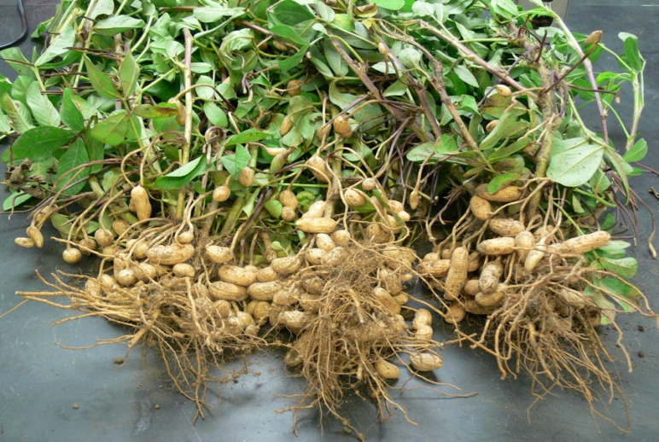
- Soil:- The crop can be grown with a minimum rainfall of 500 mm and maximum of 1250 mm. Sandy-loam soils rich in organic matter is considered as best.

- Sowing time: Kharif-groundnut- June to July subject to onset of monsoon, Rabi groundnut-November and Summer groundnut-February-March.

- Method of sowing: Line / criss-cross sowing on flat beds, sowing on BBF/RF

- Seed treatment:- Thiram/Mancozeb (3g/kg of kernel) or Carbendazim (2g/kg)

- Seed rate:- 100-110 kg seed/ha with 30x10 and a plant population of 3.33 lakh per ha for bunch type groundnut varieties and 95-100 kg seed per ha for spreading and semi-spreading varieties with a spacing of 45 x 10 cms and a plant population of 2.22 lakh per ha.

- Inter cropping:- Inter-cropping of arhar with groundnut for risk management under drought prone areas

- Nutrient Management:- For every one tonne of pod yield and two tonne of haulm yield, groundnut crop removes 60 kg Nitrogen, 11 kg Phosporous, 46 kg Potacium, 27 kg Calcium and 14 kg Magnisium from the soil. Use of NPK and micro-nutrients as per Soil-Health Card.

- Weed Management:- Two hand weeding, first around 20 days after sowing and ^{2nd} at about 35 days after sowing. Use of herbicides Pendimethalin, Oxyfluorfe, Quizalofop ethyl and Imazethapyr as per recommended dozes

- Water Management:- Rainfall/protective irrigation is necessary at flowering (20-40 DAS), pod formation (40-70 DAS) and pod filling (70-100 DAS), Sprinkler irrigation is ideal for the crop grown under sandy soils. Use of Broad-Bed-Furrow / Ridge and Furrow system for effective water / moister management. Drip irrigation is becoming popular among groundnut growers as it increases crop yield by 25-40% besides improving seed quality and saves up to 40-50% irrigation water compared to flood irrigation.
- Pest and Disease Management:-
  - White grub, aphids, thrips, caterpillars, collar rot, peanut, bud necrosis are the major insect pest in groundnut.

  - Growing of resistant varieties like, BR 2, ICGV 87160, ICGV 86031, ICGV 86699 against leaf mine;r ICGV 86590 against spodoptera; BG 2, Girnar 1 against aphids; Girnar 1, Co-1, Dh-3-30, ICGS 11, MH 1, POL 2, S 206 against leafhoppers and Girnar 1 against thrips.

  - Spray neem oil @5ml/lt water alongwith suitable surfactant like soap powder @ 1g/lt or NSKE 5% as it acts as oviposition deterrent.

  - Release of Trichogramma chilonis @ 50000/ha, two times at 7-10 days interval followed by release of Bracon hebetor @ 5000/ha two times at 7-10 days against Leaf Miner and Defoliators.

  - Install pheromone traps @ 10 traps/ha for Spodoptera and Helicoverpa and 25 traps/ha for leaf miner.

  - Erect bird perches @ 10-12/ha.

  - Soil application of neem cake or castor cake @ 500kg/ha or neem seed kernel powder @ 3-5%.

  - Seed treatment with commercial formulation of Trichoderma harzianum or T. viride or Pseudomonas fluorescens @ 10g/kg seed or Thiram or Carbendazim or Captan or Mancozeb @ 3-4g/kg seed or Tebuconazole (Raxil 2 % DS) @ 1.25g/kg.

  - Foliar application of Carbendazim (0.025%) + Mancozeb (0.2%) at 2-3 weeks interval, 2 or 3 alternate spray of Mancozeb (0.2 %), Carbendazim (0.02 %) and Mancozeb (0.2 %) or three sprays of Chlorothalonil (0.2 %) or Hexaconazole (0.005 %) or Difenoconazole 25% EC @ 2ml/L at 30, 50 and 70 DAS effectively reduces the early leaf spot and late leaf spot severity.
  - Spray Mancozeb (0.2 %) or Copper Oxychloride (0.2 %) and destroy the collateral weeds and self-sown plants.

- Harvesting:- Pods with prominent veins, dark coloured inside of the shells and the kernels are the indicatives maturity of crop.

