Package of Practices (PoP) of Castor (Ricinus communis)
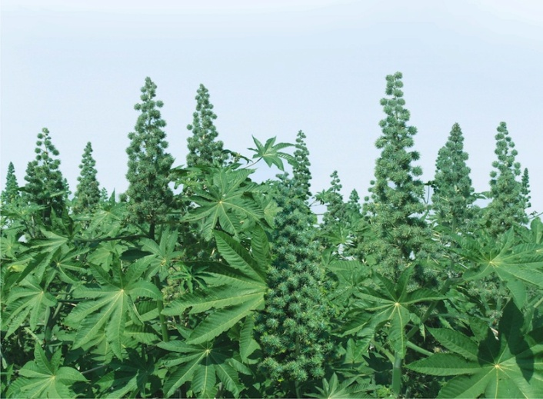
- Climate and soil:- Castor is tolerant to drought and grows well in relatively dry and warm regions. The crop comes up well on almost all types of well drained soil, but generally grown on red sandy loams in peninsular India and light alluvial soils in northern states.

- Sowing time:- Normally, rainfed crop is sown subject to receipt of monsoon and irrigated crop which is largely hybrid is sown late upto end of August. Purchase of hybrid seeds every year and renewal of seed stock of improved varieties once in 4-5 years.

- Seed treatment:-Seeds treatment with Thiram or Captan @ 3g/kg seed or Carbendazim 2 g/kg to protect plants from seed borne diseases like Alternaria Leaf Blight, Seedling Blight and Wilt. Treat the seed with Trichoderma viride @ 10 g/kg seed and soil application of 2.5 kg incubated in 125 kg FYM/ha for managing wilt.

- Seed rate:-Plant population of 18,500/ha and 14,000/ha was found to be optimum for rainfed and irrigated areas respectively with 5 kg seeds/ha.

- Spacing:- Square planting at 75 cm x 75 cm for rainfed areas and 90 cm x 90 cm for irrigated area.

- Method of sowing:- Castor is generally sown behind the country plough in Andhra Pradesh. Seed-cum-fertilizer drill can also be used.

- Nutrient Management:- Castor crop with an yield of 10 qtl./ha removes 40 kg N, 9 kg P₂0₅ and 16 kg K₂0/ha under rainfed conditions, whereas, an irrigated crop with an yield of 22.8 q/ha removes 84 kg N, 26 kg P₂0₅ and 31 kg K₂0/ha. Application of fertilizer may be decided as per soil health card.

- Weed Management:- Two or three weedings at intervals of 15-20 days in order to keep weeds under check. Alternatively preplant application of herbicides such as Fluchloralin or Trifluralin @ 1.0 kg a.i./ha or pre-emergence application of Alachlor @ 1.25 kg a.i./ha is equally effective under irrigation.

- Water Management:- For realizing the full productivity potential, the first irrigation should be applied at around 55-75 days or around full flowering of primary spike. All hybrids/varieties require 5-7 irrigations in sandy loam soils of Gujarat and Rajasthan for realizing the full productivity potentials. Drip irrigation in hybrid castor saves 24% water and offers 36% higher yield.

- Pest and diseases Management:- Semilooper is a major problem in castor. Hand picking of older larvae during early stages of crop growth.Manipulate parasitic activity by avoiding chemical spray, when 1-2 larval parasites are observed on castor plant.Spray of Monocrotophos (0.05%), Endosulfan (0.07%), if 4-5 semiloopers/ plant are observed with more than 25% defoliation.

- Harvesting:- Physiological maturity in castor is attained when some of the capsules in a spike turn brown in colour.

- Yield:-
- Rainfed condition – 800-1000 kg/ha
- Irrigated condition – 1500-2500 kg/ha

